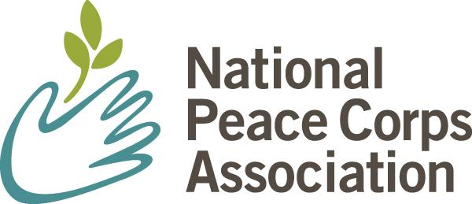

20 F Street NW, 7th Floor, Washington DC 20001

**phone** 202.293.7728 **web** PeaceCorpsConnect.org

*The Next Step in Changing the World*

**(PLEASE NOTE: Slight adjustments to this letter will be made as needed – for example, the date the letter will be issued, the bill number for pending House legislation, etc.)**

September __, 2025

Dear Members of Congress,

We are writing to join the non-governmental National Peace Corps Association in asking that you introduce (or co-sponsor) legislation as soon as possible to honor the Peace Corps and the nearly 250,000 serving and returned Peace Corps Volunteers with a Congressional Gold Medal.

This is the perfect moment to honor the Peace Corps and recognize its significant contribution to our national story. While we prepare to celebrate our nation's 250th anniversary next year, 2026 will also mark the 65th anniversary of the Peace Corps. A Congressional Gold Medal would demonstrate our nation’s highest appreciation for distinguished achievements and contributions to world peace and friendship by tens of thousands of Peace Corps Volunteers from every state and congressional district across the United States.

Please honor Peace Corps service with your support.

Sincerely,

(Name) (Name)

(Title) (Title)

(Organization) (Organization)

(City, State) (City, State)